**STEAK DONENESS CHART**

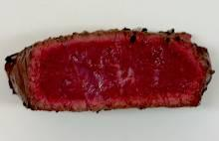

**BLUE RARE** Caramelized on the outside, bright red throughout

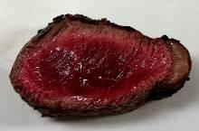

**RARE** Caramelized outside and still red 75% through the center

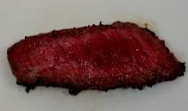

**MEDIUM RARE** Caramelized outside with 50% red center

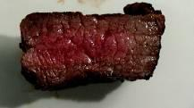

**MEDIUM** Caramelized outside, pink throughout center

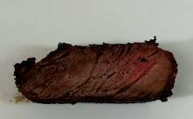

**MEDIUM WELL** Caramelized outside, slight hint of pink

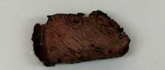

**WELL DONE** Broiled until 100% brown throughout, no pink at all